

***Green University of Bangladesh***

Department of Computer Science and Engineering

**Group Lab project**

Course Title: Digital Logic Design Lab

Course code: CSE 204

Date of Submission: 18.04.2021

|  |  |
| --- | --- |
| Submitted to:  Name : Md. Atikuzzaman  Designation : Lecturer  Department : CSE  Green university of Bangladesh | Submitted by :  Name : Jakirul Islam  ID : 193002101  Department : CSE  Name : Md.Nur A Neouse  ID : 193002093  Department : CSE |

**Traffic Light Controller**

**Outline**

* Abstract
* Introduction
* Components
* Component Description
* Block Diagram
* Project Images
* Project Code
* Limitations
* Applications

**Abstract :** The function of traffic light is to provide sophisticated control and coordination to ensure that traffic moves as smoothly and safely as possible

**Introduction :** This project uses a LED light as an indicator. A microcontroller for auto change signal after a specific time interval. The LEDs are automatically on and off by making the corresponding port pin of the microcontroller high

**Components Required**

* Arduino UNO Board
* Red, Green, Yellow(amber) LED’s
* Resistors
* Breadboard
* Power supply

**Component Description**

**Arduino UNO**: The main part of the Traffic Light Controller is the controller itself. Arduino UNO will serve the purpose in this project to handle all the switching of the LEDs and controlling their timings.

**Control Lights indication:**

There are three control lights or signals, which will provide the instruction to the driver.

RED light – instructs the driver to STOP at the intersection.

YELLOW light – instructs the driver to WAIT (If red light is next) or GET READY (if green light is next)

GREEN light – instructs the driver to GO through the intersection.

**Block Diagram:**

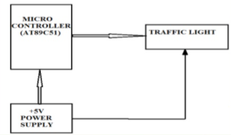

**Project Images**

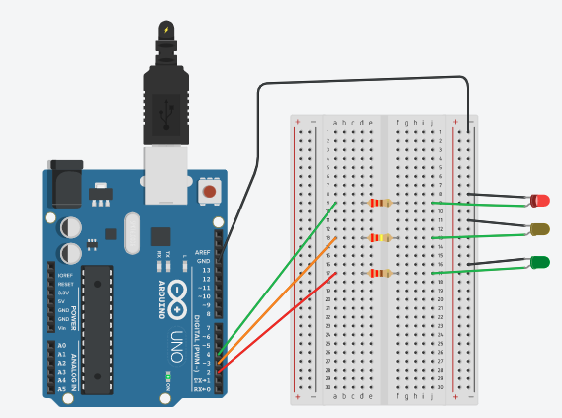 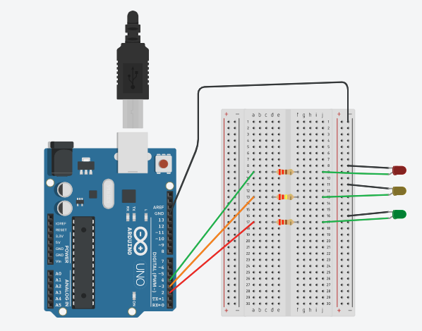

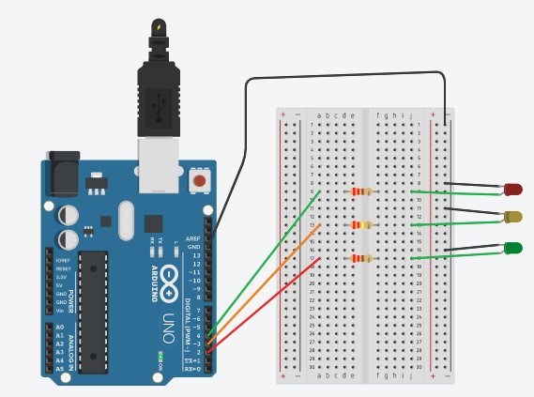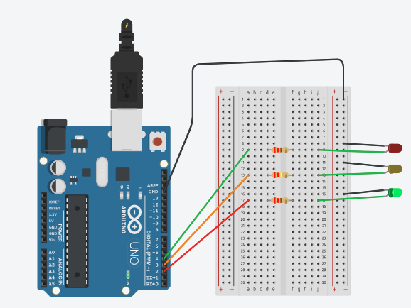

**Project Code**

void setup()

{

pinMode(4, OUTPUT);

pinMode(3, OUTPUT);

pinMode(2, OUTPUT);

}

void loop()

{

digitalWrite(4, HIGH); // For Red LED

delay(15000); // Wait for 15 second

digitalWrite(4, LOW);

digitalWrite(3, HIGH); // For Yellow LED

delay(5000); // Wait for 5 second

digitalWrite(3, LOW);

digitalWrite(2, HIGH); // For the red LED

delay(15000); // Wait for 15 second

digitalWrite(2, LOW);

}

**Limitations**

The project is not suitable for actual implementation but just a demonstration of the process behind the system.

Real time traffic light controller systems are generally run time programmable i.e. the operator (usually a policeman) can change the timings of each lane as per the intensity of the traffic in each lane.

There will also be a provision for either manual operation or pre-programmed operation.

**Applications**

1. Ramp metering

2. Timer

3.Fire station or medical emergency entrance

4.At the entrance and exit of some car washes

5. At the landing stage of a ferry and abroad the ferry